**PROJECT: SPICEJET**

**BUG ID**: 01

**BUG NAME**: Spelling mistake of “spiceholidays” on home page.

**ASSIGNEE**: New assigned

**STATE**: New

**DESCRIPTION**: 1. Open spicejet application.

2. In home page on headline bar.

3.Please refer the screenshot

**OBSERVATION**: Here the word is spiceholidays.

**EXPECTED**: The correct word is spiceholiday

**PRIORITY**: Low

**SEVERITY**: Low

**ATTACHMENT**: 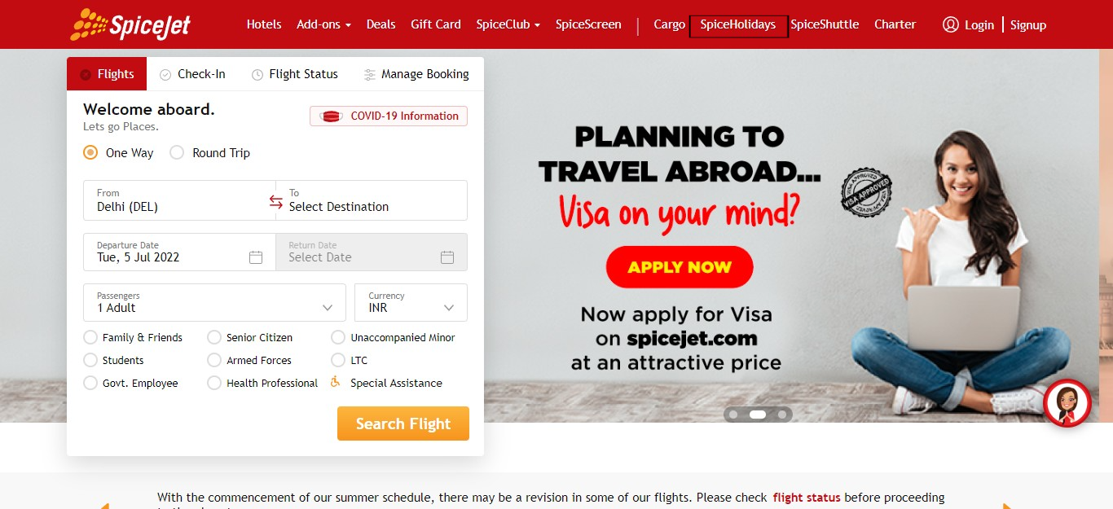

**BUG ID**: 02

**BUG NAME**: After selecting From region, TO dropdown should not have same region.

**ASSIGNEE**: New assigned

**STATE**: New

**DESCRIPTION**: 1. Open spicejet application in home page.

2.select location on FROM point.

3.Click on TO dropdown.

4.Please refer the screenshot.

**OBSERVATION**: Same location is present in To dropdown.

**EXPECTED**: From location should not present here.

**PRIORITY**: High

**SEVERITY**: Low

**ATTACHMENT**: 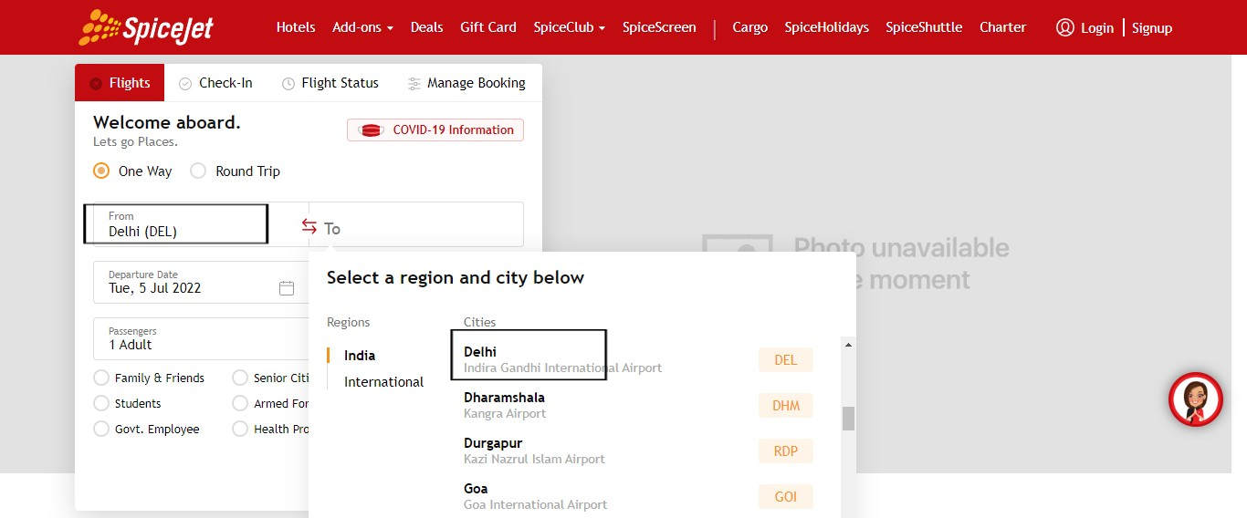

**BUG ID**: 03

**BUG NAME**: Select one way trip, Enable the return date

**ASSIGNEE**: New assigned

**STATE**: New

**DESCRIPTION**: 1.Open spicejet application on home page.

2. To select one way trip.

3.Please refer the screenshot.

**OBSERVATION**: Return date can be invisible.

**EXPECTED**: But here, return date can be enable.

**PRIORITY**: Medium

**SEVERITY**: High

**ATTACHMENT**:

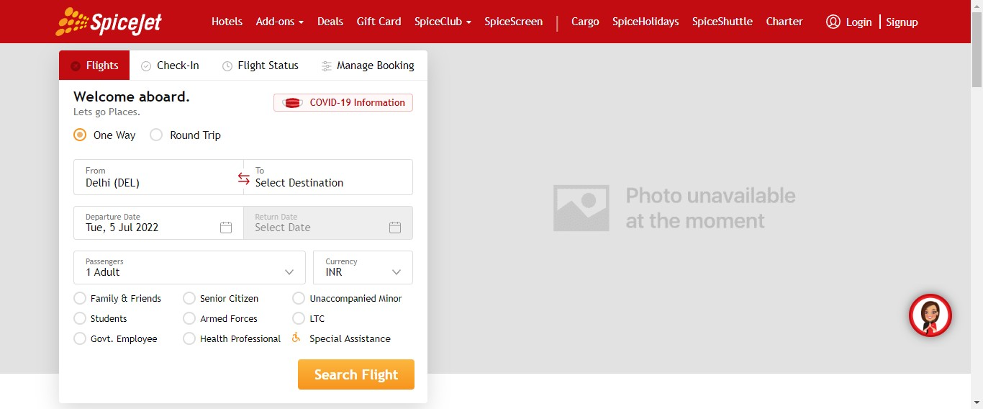

**BUG ID**: 04

**BUG NAME**: Click travel guidelines, It can’t be open.

**ASSIGNEE**: New assigned

**STATE**: New

**DESCRIPTION**: 1.Open spicejet application on home page.

2.Go bottom of the page click covid info icon.

3.Click travel guidelines.

4.Please refer the screenshot.

**OBSERVATION**: Travel guidelines cannot be open.

**EXPECTED**: Travel guidelines to open.

**PRIORITY**: High

**SEVERITY**: High

**ATTACHMENT**:

